**Table of Contents**

|  |  |  |
| --- | --- | --- |
| **Sl. No** | **Contents** | **Page No.** |
| 1 | Introduction | 1 |
| 2 | Problem Statement | 3 |
| 3 | System Design | 4 |
| 4 | Implementation | 5-13 |
| 5 | Results | 14-15 |
| 6 | Conclusion and Future enhancements | 16-17 |
| 7 | References | 18 |

**List of Figures**

|  |  |  |
| --- | --- | --- |
| **Figure No.** | **Contents** | **Page No.** |
| 1.1 | Conversion | 2 |
| 2.1 | Problem Statement | 3 |
| 3.1 | System Design | 5-13 |
| 5.1 | Result image1 | 14 |
| 5.2 | Result image2 | 14 |
| 5.3 | Result image3 | 15 |

**Chapter 1**

**INTRODUCTION**

**Background Information:**

Brick Breaker is a classic arcade game where the player controls a paddle to bounce a ball and break bricks arranged at the top of the screen. The objective is to clear all the bricks using the ball without letting it fall off the bottom of the screen. Developed in Java, the game utilizes object-oriented programming principles to organize its components into classes such as the paddle, ball, bricks, and game manager.

**Objectives and Scope:**

**Objectives:**

* **Create a Functional Game:** Develop a fully functional Brick Breaker game that provides an engaging and enjoyable gaming experience for players.
* **Implement Core Gameplay Mechanics:** Ensure that the game accurately reflects the classic Brick Breaker gameplay, including paddle and ball physics, brick breaking, and collision detection.
* **Design Visually Appealing Graphics:** Create visually appealing graphics and user interface elements that enhance the overall presentation of the game.
* **Provide Smooth User Experience:** Optimize the game's performance to provide smooth and responsive gameplay, minimizing lag or delays in user interactions.

**Scope:**

* Gameplay Mechanics
* Graphics and User Interface
* Levels and Difficulty
* Power-ups and Bonuses (Optional)

**Brief Overview of Methodology or Approach:**

The methodology or approach to developing a Brick Breaker game using Java typically involves the following steps:

**Requirement Analysis**: Understand the requirements and objectives of the game, including its core mechanics, features, and target audience.

**Design Planning**: Plan the design and architecture of the game, including class structures, game states, user interface elements, and graphical assets.

**Implementation:** Write the code to implement the game mechanics, graphics rendering, user input handling, scoring system, and optional features such as power-ups.

**Testing and Debugging:** Test the game thoroughly to identify and fix any bugs or issues, ensuring that the gameplay is smooth and the user experience is satisfactory.

I**terative Development:** Continuously iterate on the game, incorporating feedback, optimizing performance, and adding additional features or improvements.

**Deployment:** Prepare the game for deployment by packaging it into a standalone executable or web application, ensuring compatibility across different platforms and environments.

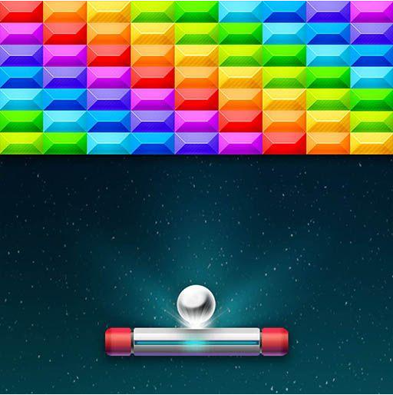

Figure 1.1. Brick breaker game

**Chapter 2**

**PROBLEM STATEMENT**

Develop a Brick Breaker game using Java programming language. The game should feature classic Brick Breaker gameplay mechanics, where the player controls a paddle to bounce a ball and break bricks arranged at the top of the screen. The objective is to clear all the bricks without letting the ball fall off the bottom of the screen. The game should include multiple levels with increasing difficulty, power-ups, scoring system, and smooth user interface. Optional features such as sound effects and music may be implemented to enhance the gaming experience. The game should be visually appealing, intuitive to play, and free of bugs or glitches.

This problem statement serves as a guideline for developers to understand the scope and objectives of the Brick Breaker game project and to ensure that the final product meets the desired requirements.



Figure 2.1. Problem Statement

**Chapter 3**

**SYSTEM DESIGN**

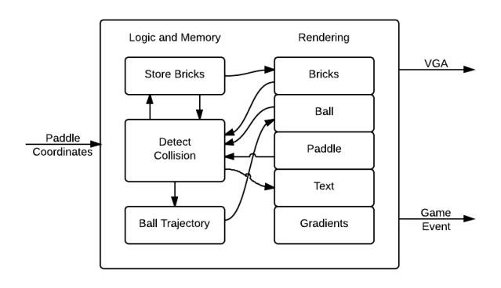

Figure 3.1. System Design

The system design of the brick breaker game implemented in Java revolves around key components such as the paddle, ball, bricks, and game engine. Following an object-oriented approach, classes are designed for each element to encapsulate their behavior and interactions. The game engine manages the game state, rendering graphics using Java libraries, and handling user input.

**Chapter 4**

**IMPLEMENTATION**

**Details about the actual implementation of the project:**

Java Implementation

1. Main Method:

- This is the entry point of the program. It creates a JFrame, adds the game panel to it, and starts the game loop.

2. newbrickbreaker() Constructor:

-This constructor initializes the game by setting up the panel, adding key listeners, creating bricks, paddle, and ball objects, and starting a timer for game updates.

JavaScript Implementation:

1. Constants and State Initialization:

- It defines the API key (`key`) and the initial state of the application (`state`), including the base and target levels, etc.

2. User Interface (UI) Elements:

- Although not explicitly shown in the provided snippet, the actual implementation would include definitions of UI elements such as buttons, input fields, and containers.

createBricks() Method:

This method is responsible for creating the bricks layout. It iterates over rows and columns to create bricks at specific positions and adds them to the bricks ArrayList.

paintComponent(Graphics g) Method:

-This method is called whenever Swing determines that the component needs to be repainted. It draws the game elements (paddle, ball, bricks) on the panel along with the score and high score.

update() Method:

-This method updates the game state by moving the paddle, ball, checking for collisions between the ball and paddle/bricks, and updating the score. It also checks if all bricks are destroyed and ends the game if so.

restart() Method:

-This method resets the game state, including score, bricks, paddle, and ball, to restart the game.

keyPressed(KeyEvent e) Method:

-This method is called when a key is pressed. It handles keyboard input for moving the paddle and restarting the game.

keyReleased(KeyEvent e) Method:

-This method is called when a key is released. It stops the paddle's movement when the corresponding keys are released.

keyTyped(KeyEvent e) Method:

-This method is called when a key is typed. It's not used in this code.

actionPerformed(ActionEvent e) Method:

-This method is called when an action event occurs. It updates the game state and repaints the panel.

Each method plays a crucial role in managing different aspects of the Brick Breaker game, including initialization, updating game state, handling user input, and rendering the game on the screen.

**Java pseudo-code**

cimport javax.swing.*;

import java.awt.*;

import java.awt.event.*;

import java.util.ArrayList;

import java.util.Iterator;

import javax.swing.JFrame;

import java.awt.Font;

import javax.swing.JOptionPane;

public class newbrickbreaker extends JPanel implements KeyListener, ActionListener {

private Timer timer;

private ArrayList<Brick> bricks;

private Paddle paddle;

private Ball ball;

private int score = 0;

private int highScore = 0;

private boolean gameRunning = true;

private boolean multiplayer = false;

private Paddle paddle2;

public newbrickbreaker() {

this.setFocusable(true);

this.requestFocusInWindow();

this.addKeyListener(this);

this.setPreferredSize(new Dimension(800, 600));

bricks = new ArrayList<>();

createBricks();

paddle = new Paddle(350, 550, 100, 10);

if (multiplayer)

paddle2 = new Paddle(350, 530, 100, 10);

ball = new Ball(390, 525, 10, 10);

ball.setGame(this); // Pass the game instance to the ball

timer = new Timer(1000 / 60, this);

timer.start();

}

private void createBricks() {

for (int i = 0; i < 8; i++) {

for (int j = 0; j < 6; j++) {

Brick brick = new Brick(10 + i * 90, 50 + j * 40, 80, 30);

bricks.add(brick);

}

}

}

public void paintComponent(Graphics g) {

super.paintComponent(g);

Graphics2D g2 = (Graphics2D) g;

if (gameRunning) {

paddle.draw(g2);

if (multiplayer)

paddle2.draw(g2);

ball.draw(g2);

for (Brick brick : bricks) {

brick.draw(g2);

}

g2.setColor(Color.BLACK);

g2.setFont(new Font("Arial", Font.PLAIN, 20));

g2.drawString("Score: " + score, 20, 30);

g2.drawString("High Score: " + highScore, 20, 60);

} else {

g2.setColor(Color.BLACK);

g2.setFont(new Font("Arial", Font.PLAIN, 50));

g2.drawString("Game Over", 280, 250);

g2.drawString("Score: " + score, 310, 320);

g2.drawString("Press R to restart", 240, 390);

}

}

public void update() {

if (gameRunning) {

paddle.move();

if (multiplayer)

paddle2.move();

ball.move();

ball.checkCollision(paddle);

if (multiplayer)

ball.checkCollision(paddle2);

Iterator<Brick> iterator = bricks.iterator();

while (iterator.hasNext()) {

Brick brick = iterator.next();

if (ball.checkCollision(brick)) {

iterator.remove(); // Safely remove the current brick

score += 10;

break;

}

}

if (bricks.isEmpty()) {

gameRunning = false;

if (score > highScore)

highScore = score;

}

}

}

public void restart() {

score = 0;

gameRunning = true;

createBricks();

paddle = new Paddle(350, 550, 100, 10);

if (multiplayer)

paddle2 = new Paddle(350, 530, 100, 10);

ball = new Ball(390, 525, 10, 10);

ball.setGame(this); // Pass the game instance to the ball

}

public void keyPressed(KeyEvent e) {

int keyCode = e.getKeyCode();

if (keyCode == KeyEvent.VK_LEFT) {

paddle.setVelX(-5);

}

if (keyCode == KeyEvent.VK_RIGHT) {

paddle.setVelX(5);

}

if (multiplayer) {

if (keyCode == KeyEvent.VK_A) {

paddle2.setVelX(-5);

}

if (keyCode == KeyEvent.VK_D) {

paddle2.setVelX(5);

}

}

if (keyCode == KeyEvent.VK_R) {

if (!gameRunning)

restart();

}

}

public void keyReleased(KeyEvent e) {

int keyCode = e.getKeyCode();

if (keyCode == KeyEvent.VK_LEFT || keyCode == KeyEvent.VK_RIGHT) {

paddle.setVelX(0);

}

if (multiplayer) {

if (keyCode == KeyEvent.VK_A || keyCode == KeyEvent.VK_D) {

paddle2.setVelX(0);

}

}

}

public void keyTyped(KeyEvent e) {

}

public void actionPerformed(ActionEvent e) {

update();

repaint();

}

public static void main(String[] args) {

SwingUtilities.invokeLater(() -> {

JFrame frame = new JFrame("Brick Breaker");

newbrickbreaker game = new newbrickbreaker();

frame.add(game);

frame.pack();

frame.setDefaultCloseOperation(JFrame.EXIT_ON_CLOSE);

frame.setLocationRelativeTo(null);

frame.setVisible(true);

String playerName = JOptionPane.showInputDialog(null, "Enter your name:", "Player Name", JOptionPane.INFORMATION_MESSAGE);

// If user clicks Cancel or closes the dialog, playerName will be null

if (playerName == null || playerName.trim().isEmpty()) {

playerName = "Player"; // Default name if none provided

}

});

}

}

public static class Ball {

public Ball(int par, int par1, int par2, int par3, newbrickbreaker aThis) {

}

private Ball(int i, int i0, int i1, int i2) {

throw new UnsupportedOperationException("Not supported yet."); // Generated from nbfs://nbhost/SystemFileSystem/Templates/Classes/Code/GeneratedMethodBody

}

private void draw(Graphics2D g2) {

throw new UnsupportedOperationException("Not supported yet."); // Generated from nbfs://nbhost/SystemFileSystem/Templates/Classes/Code/GeneratedMethodBody

}

private void move() {

throw new UnsupportedOperationException("Not supported yet."); // Generated from nbfs://nbhost/SystemFileSystem/Templates/Classes/Code/GeneratedMethodBody

}

private void checkCollision(Paddle paddle) {

throw new UnsupportedOperationException("Not supported yet."); // Generated from nbfs://nbhost/SystemFileSystem/Templates/Classes/Code/GeneratedMethodBody

}

private Object getBounds() {

throw new UnsupportedOperationException("Not supported yet."); // Generated from nbfs://nbhost/SystemFileSystem/Templates/Classes/Code/GeneratedMethodBody

}

private void setGame(newbrickbreaker aThis) {

throw new UnsupportedOperationException("Not supported yet."); // Generated from nbfs://nbhost/SystemFileSystem/Templates/Classes/Code/GeneratedMethodBody

}

private boolean checkCollision(Brick brick) {

throw new UnsupportedOperationException("Not supported yet."); // Generated from nbfs://nbhost/SystemFileSystem/Templates/Classes/Code/GeneratedMethodBody

}

}

**Chapter 5**

**RESULT**

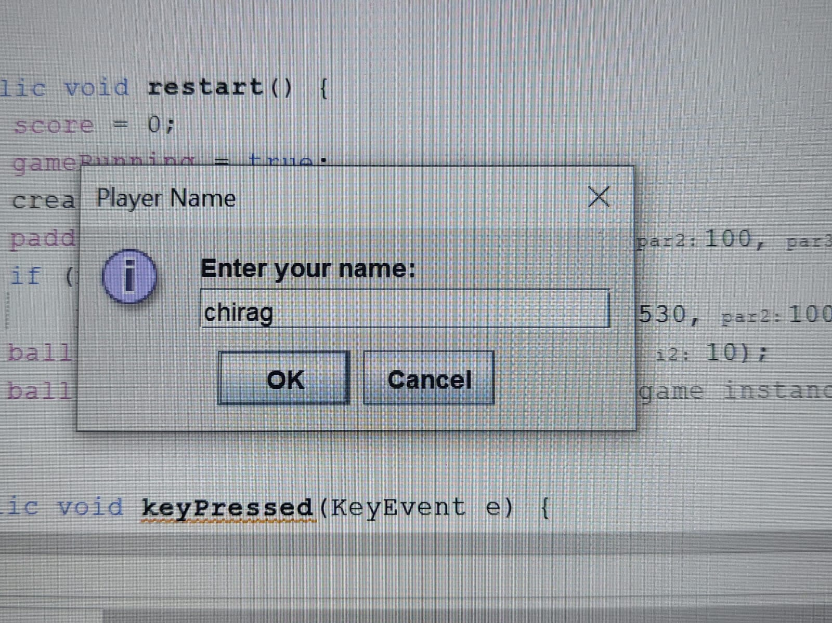

Figure 5.1. Database

Database

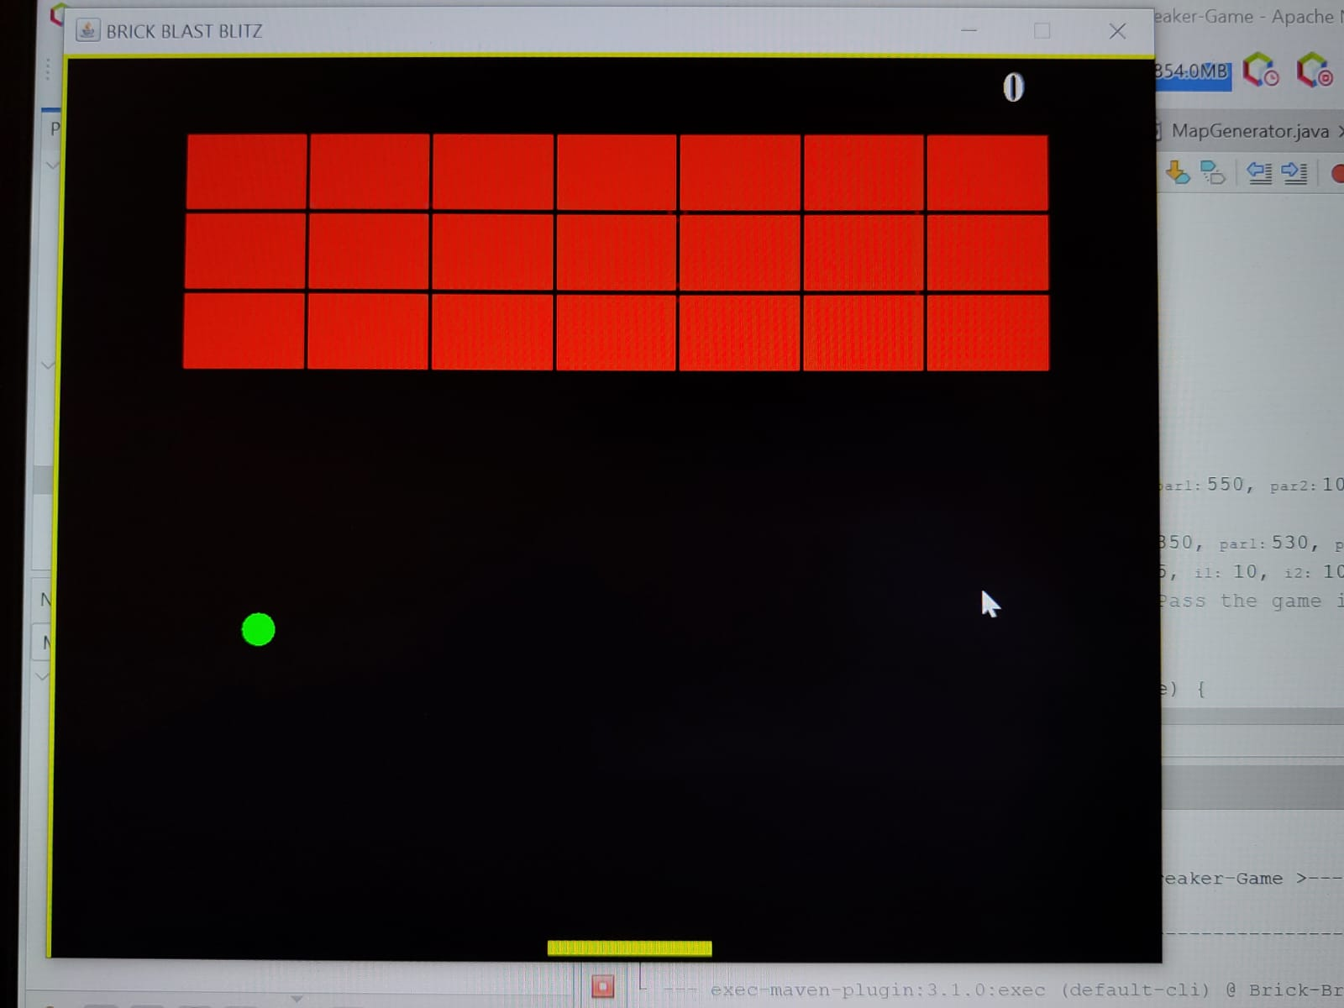

Figure 5.2.Game Play

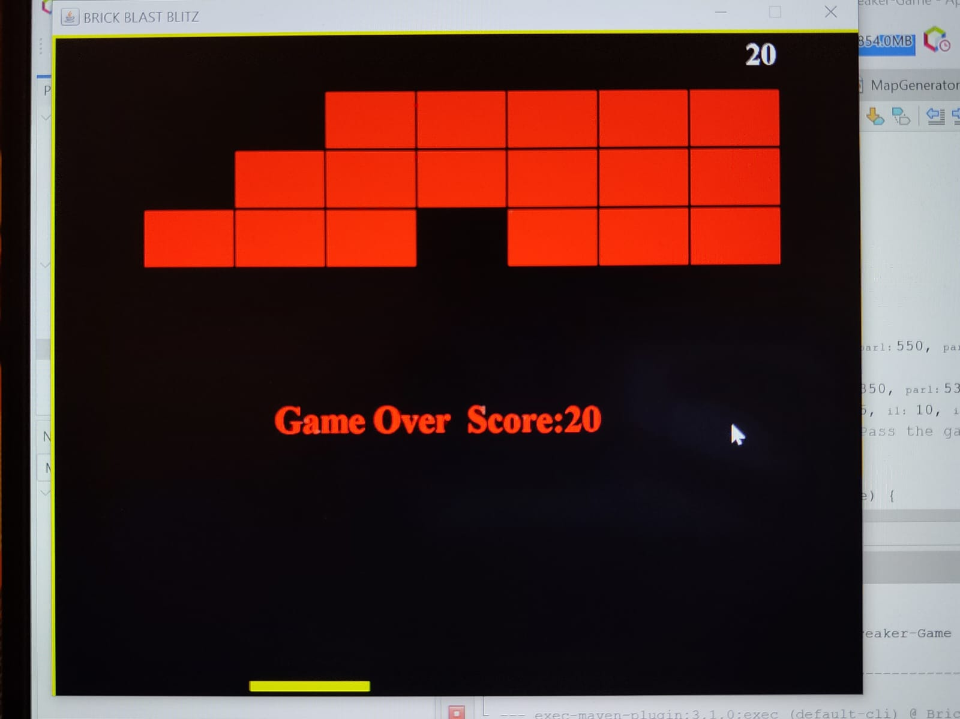

Figure 5.3. Game Control

**Chapter 6**

**CONCLUSION AND FUTURE ENHANCEMENTS**

In conclusion, the provided code implements a simple Brick Breaker game using Java Swing. It features a paddle controlled by the player, a ball that bounces around the screen, and bricks that the player must destroy with the ball. The game keeps track of the player's score and highest score achieved.

Overall, the implementation covers the basic functionality of a Brick Breaker game, including gameplay mechanics, collision detection, scoring, and game over conditions. However, there are several areas where future enhancements could be made to improve the game:

* **Graphics and User Interface Enhancements:**

Adding more visually appealing graphics, animations, and sound effects can enhance the overall gaming experience.

Implementing a main menu, level selection, and pause menu can improve user interaction and navigation within the game.

* **Gameplay Features:**

Introducing power-ups such as multi-ball, larger paddle, or explosive bricks can add variety and excitement to the gameplay.

Implementing different levels with increasing difficulty, varying brick layouts, and obstacles can provide more challenges for players.

* **Multiplayer Mode:**

Enhancing the game to support multiplayer mode where two players can compete or cooperate in breaking bricks can make the game more engaging.

Adding networking capabilities to enable online multiplayer functionality can expand the game's audience and replay value.

* **Scoreboard and Achievements:**

Implementing a scoreboard to track high scores and achievements can encourage competition among players and provide additional goals to strive for.

Introducing unlockable achievements or challenges for completing specific objectives can add depth and replayability to the game.

* **Optimization and Performance:**

Optimizing the code for better performance, especially in collision detection and rendering, can ensure smooth gameplay on different devices.

Implementing techniques such as double buffering, object pooling, and efficient data structures can improve the game's efficiency and responsiveness.

**References:**

* [https://github.com/topics/brick-breaker](https://github.com/topics/brick-breaker https:/stackoverflow.com/questions/62703039/brick-bracker-game-with-java https:/itsourcecode.com/free-projects/java-projects/brick-breaker-game-in-java-with-source-code/ )
* [https://stackoverflow.com/questions/62703039/brick-bracker-game-with-java](https://github.com/topics/brick-breaker https:/stackoverflow.com/questions/62703039/brick-bracker-game-with-java https:/itsourcecode.com/free-projects/java-projects/brick-breaker-game-in-java-with-source-code/ )
* [https://itsourcecode.com/free-projects/java-projects/brick-breaker-game-in-java-with-source-code/](https://github.com/topics/brick-breaker https:/stackoverflow.com/questions/62703039/brick-bracker-game-with-java https:/itsourcecode.com/free-projects/java-projects/brick-breaker-game-in-java-with-source-code/ )